**Manuscript Title (16, Times New Roman, Bold)**

First Author 1*, andSecond Author2

1 Department, Faculty, University, City, Country

2 Department, Faculty, University, City, Country

**\* Email (for reference researcher):** [**xxxxxxxx@xxxx.com**](mailto:xxxxxxxx@xxxx.com)

**عنوان المقال (باللغة العربية) (Times New Roman) (16 حجم غليظ)**

اسم ولقب المؤلف الأول1*، اسم ولقب المؤلف الثاني 2 (حجم 12)

**1** القسم، الكلية، الجامعة، المدينة، الدولة

**2** القسم، الكلية، الجامعة، المدينة، الدولة

Received: 02-04-2025; Accepted: 17-05-2025; Published: 01-06-2025

**Abstract:**

(Times New Roman: size - 12) Abstract must be written in English within 300 words.

........................................................................................................................................................................................................................................................................................................................................................................................ .

يجب ألا تكون المضامين المحررة باللغة الإنجليزية (العنوان، الملخص، الكلمات المفتاحية) مترجمة ترجمة آلية تحت طائلة رفض المقال.

**Keywords:** word; word; word; (not more than 7 words).

**الملخص:**

في حدود 300 كلمة، Times New Roman) - حجم 14)

.......................................................................................................................................................................................................................................................................................................................................................................................................................................................................................................................... .

**الكلمات المفتاحية:** كلمة، كلمة، كلمة، ... (في حدود 7 كلمات).

**Introduction**

The introduction should be typed in Times New Roman with font size 12. Author can select Normal style setting from Styles of this template. The simplest way is to replace (copy-paste) the content with your own material. In this section, highlight the importance of topic, making general statements about the topic and presenting an overview on current research on the subject. Your introduction should clearly identify the subject area of interest.

Reference should be cited at appropriate point in the text by number(s) in square brackets in line with the text. e.g.: '..... was reported earlier [1, 2].'

The actual authors can be referred to, but the reference number(s) must always be given. e.g.: 'Barnaby and Jones [3] obtained a different....'

The introduction should be typed in Times New Roman with font size 12. Author can select Normal style setting from Styles of this template. The simplest way is to replace (copy-paste) the content with your own material. In this section, highlight the importance of topic, making general statements about the topic and presenting an overview on current research on the subject. Your introduction should clearly identify the subject area of interest.

The introduction should be typed in Times New Roman with font size 12. Author can select Normal style setting from Styles of this template. The simplest way is to replace (copy-paste) the content with your own material. In this section highlight the importance of topic, making general statements about the topic and presenting an overview on current research on the subject. Your introduction should clearly identify the subject area of interest.

**Material and methods**

The materials and methods should be typed in Times New Roman with font size 12 and justify alignment. Author can select Normal style setting from Styles of this template. The simplest way is to replace (copy-paste) the content with your own material. Method and analysis which is performed in your research work should be written in this section. A simple strategy to follow is to use keywords from your title in first few sentences.

**Results and discussion**

This section should be typed in character size 12 Times New Roman and alignment justified. Author can directly select Normal style from styles of this template. The results and discussion may be combined into a common section or obtainable separately. They may also be broken into subsets with short, revealing captions. An easy way to comply with the conference paper formatting requirements is to use this document as a template and simply type your text into it.

All tables should be inserted in the main text article at its appropriate place.

**Table 1** Table title should be of font size 12, Times New Roman, justfy

|  |  |  |  |
| --- | --- | --- | --- |
| **SN.** | **Model Type** | **Seismic Zone** | **Displacement** |
| 1 | Model-A | 4 | 10.044 mm |
| 2 | Font size 12 | Times New Roman | No space after paragraph |
| 3 | Font size 12 | Times New Roman | No space after paragraph |
| 4 | Font size 12 | Times New Roman | No space after paragraph |
| 5 | Font size 12 | Times New Roman | No space after paragraph |
| 6 | Font size 12 | Times New Roman | No space after paragraph |
| 7 | Font size 12 | Times New Roman | No space after paragraph |
| 8 | Font size 12 | Times New Roman | No space after paragraph |
| 9 | Font size 12 | Times New Roman | No space after paragraph |

Table foot note should be Font size 12, Times New Roman, Centre aligned, No space before paragraph

Result discussion section should be typed in character size 12 Times New Roman and alignment justified. Author can directly select Normal style from styles of this template. The results and discussion may be combined into a common section or obtainable separately. An easy way to comply with the conference paper formatting requirements is to use this document as a template and simply type your text into it.

All figures should be inserted in the main text document at its appropriate place. Figures should be numbered as Figure 1, Figure 2, and Figure 3 etc.

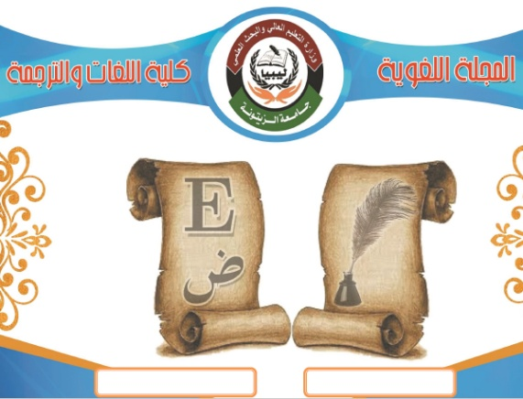

**Figure 1.** Figure caption should be of font size 12pt, Times New Roman, Centre align

Result discussion section should be typed in character size 12pt Times New Roman and alignment justified. Author can directly select Normal style from styles of this template. The results and discussion may be combined into a common section or obtainable separately. An easy way to comply with the conference paper formatting requirements is to use this document as a template and simply type your text into it.

**Conclusion**

This section should be typed in character size 12pt Times New Roman and alignment justified. All the main points of the research work are written in this section. Ensure that abstract and conclusion should not same. Conclusion should be concise, informative and can be started with summarizing outcome of the study in 1-2 sentence and ended with one line stating: how this study will benefit to the society and way forward.

**References**

The template will number citations consecutively within brackets [1]. The sentence punctuation follows the bracket [2]. Refer simply to the reference number, as in [3]—do not use “Ref. [3]” or “reference [3]” except at the beginning of a sentence: “Reference [3] was the first ...”

Number footnotes separately in superscripts. Place the actual footnote at the bottom of the column in which it was cited. Do not put footnotes in the abstract or reference list. Use letters for table footnotes.

Unless there are six authors or more give all authors’ names; do not use “et al.”. Papers that have not been published, even if they have been submitted for publication, should be cited as “unpublished” [4]. Papers that have been accepted for publication should be cited as “in press” [5]. Capitalize only the first word in a paper title, except for proper nouns and element symbols.

For papers published in translation journals, please give the English citation first, followed by the original foreign-language citation [6].

G. Eason, B. Noble, and I. N. Sneddon, “On certain integrals of Lipschitz-Hankel type involving products of Bessel functions,” Phil. Trans. Roy. Soc. London, vol. A247, pp. 529–551, April 1955. *(references)*

J. Clerk Maxwell, A Treatise on Electricity and Magnetism, 3rd ed., vol. 2. Oxford: Clarendon, 1892, pp.68–73.

I. S. Jacobs and C. P. Bean, “Fine particles, thin films and exchange anisotropy,” in Magnetism, vol. III, G. T. Rado and H. Suhl, Eds. New York: Academic, 1963, pp. 271–350.

K. Elissa, “Title of paper if known,” unpublished.

R. Nicole, “Title of paper with only first word capitalized,” J. Name Stand. Abbrev., in press.

Y. Yorozu, M. Hirano, K. Oka, and Y. Tagawa, “Electron spectroscopy studies on magneto-optical media and plastic substrate interface,” IEEE Transl. J. Magn. Japan, vol. 2, pp. 740–741, August 1987 [Digests 9th Annual Conf. Magnetics Japan, p. 301, 1982].

M. Young, The Technical Writer’s Handbook. Mill Valley, CA: University Science, 1989.